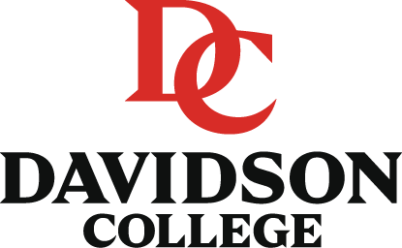
Davidson Research Initiative
Summer Research Program
Cover Letter/Recommendation Form
Request for Evaluation:
Evaluator: ____________________________________ Date: ________________________
I request that you complete this recommendation for the Davidson Research Initiative and send it to Dr. Mary Muchane at the address below. I waive ( )/do not waive ( ) my right to see this recommendation.
______________________________ _____________________________
Signature of Student Print Name of Student
Faculty Member Evaluation:
Please check the appropriate blocks below, ranking the student in the following areas that may be relevant to the proposed DRI project. Attach this form to your letter of recommendation. If you cannot provide a relevant evaluation of the student, please ask the student to find another evaluator. All written comments should be on official stationery and should be addressed to Mary Muchane, Ph.D., DRI Program Director, P.O. Box 5000, Davidson College, Davidson, NC 28035.
Evaluator’s Signature:____________________________
Indicate Comparison group:
_____ Undergraduate research or honors students _____ All undergraduate students
_____ Other (Please specify):
Please check appropriate box | Outstanding Top 1-2 % | Excellent Top 10% | Good Top 25% | Average Top 50% | Below Average Bottom 50% | Unable to Judge
Academic Performance
Academic Potential
Intellectual Curiosity
Critical/Analytical Thinking
Problem-Solving Ability
Sustained independent work
Study/Organizational/Time Management Skills
Verbal/Written Skills
Analytical Skills
Creative skills (Writing, Artistic, Performance)
Maturity/Stability
Overall Probability of Success at DRI Summer Research

